HEALTHCARE Analysis

Week4:
Statistics Analysis and Predictive Modeling

- Introduction
Statistical analysis is an important step in healthcare data analytics because it helps identify trends, relationships, and patterns in patient data. Predictive modeling uses historical data to estimate future outcomes and support healthcare decision-making. In this project, the healthcare will be analyzed using descriptive statistics and visualization techniques. Numerical and categorical variables such as age, billing amount, gender, admission type, medical condition, and test results will be examined to understand patient characteristics and healthcare patterns. In addition, a predictive modeling approach is proposed to estimate patient test results using selected healthcare features.
Healthcare organizations collect large amounts of patient information every day. Statistical analysis helps summarize this data and identify important patterns. Predictive modeling extends this analysis by using historical data to make predictions that support better planning and decision-making.
This phase of the project focuses on analyzing the healthcare dataset using statistical techniques and introducing a machine learning model for prediction.

- Task Objective

The objectives of this phase are:
- Analyze numerical and categorical variables.
- Calculate summary statistics.
- Identify relationships between variables.
- Study patient demographics.
- Analyze healthcare costs.
- Build a basic predictive model (optional).
- Interpret the results for decision-making.

Descriptive Statistical Analysis

The following statistical measures will be calculated:

Numerical Variables
- Mean
- Median
- Minimum
- Maximum
- Standard Deviation
Applied to:
- Age
- Billing Amount
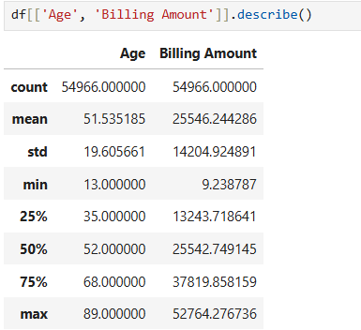

- Frequency Analysis
Frequency analysis will be performed for categorical variables such as:
- Gender
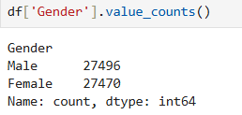
- Medical Condition
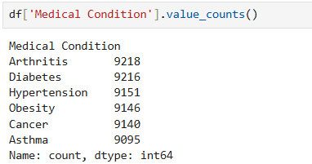
- Admission Type
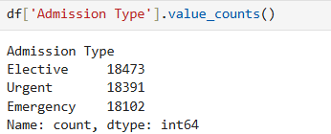
- Blood Type
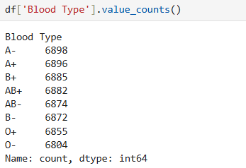
- Test Results
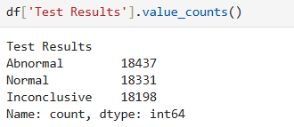

- Correlation Analysis

Relationships between numerical variables will be examined using a correlation matrix.
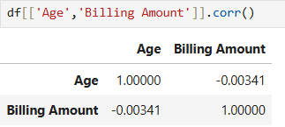

- Statistical Insight
The statistical analysis will answer questions such as:
- What is average age of patients
51.53 average age of patients.
- Which medical conditions occurs most frequently?
Arthritis is the most frequently occured medical condition.
- Which admission type is most common?
Elective admission type is most common.
- What is the average billing amount?
25546.244286 is the average billing amount
- Is there any relationship between age and billing ?
There is no significant relationship between a patient's age and their billing amount in this dataset.

- Predictive Modeling

A simple machine learning model can be developed to predict the Test Results using healthcare features.

Possible Features
- Age
- Gender
- Blood Type
- Medical Condition
- Admission Type
- Billing Amount

Target Variable
- Test Results

Suggested Algorithms
- Decision Tree
- Random Forest
- Logistic Regression

Note: As it is synthetic data accuracy can be very low.
- Python Implementation

- Importing Libraries

import pandas as pd
import numpy as np
import seaborn as sns
from sklearn.model_selection import train_test_split
from sklearn.preprocessing import LabelEncoder
from sklearn.tree import DecisionTreeClassifier
from sklearn.ensemble import RandomForestClassifier
from sklearn.linear_model import LogisticRegression
from xgboost import XGBClassifier
from sklearn.metrics import (
accuracy_score,
precision_score,
recall_score,
f1_score,
confusion_matrix,
classification_report

)

import matplotlib.pyplot as plt
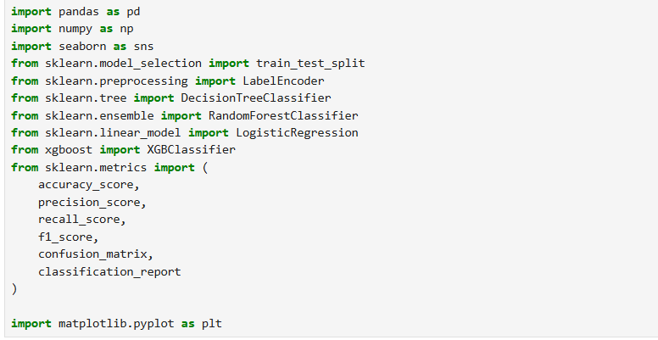

- Feature Selection
features = [
"Age",
"Billing Amount",
"Medical Condition"

target = "Test Results"

X = df[features].copy()
y = df[target]. copy()
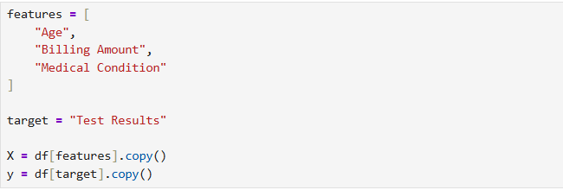

- Encode Categorical Columns
encoders = {}

for col in X.select_dtypes(include="object").columns:
le = LabelEncoder()
X[col] = le.fit_transform(X[col])
encoders[col] = le

target_encoder = LabelEncoder()
y = target_encoder.fit_transform(y)
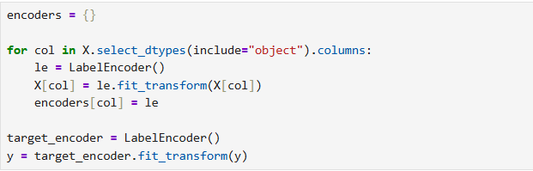
- Train test split

X_train, X_test, y_train, y_test = train_test_split(
X,
y,
test_size=0.20,
random_state=42,
stratify=y

)
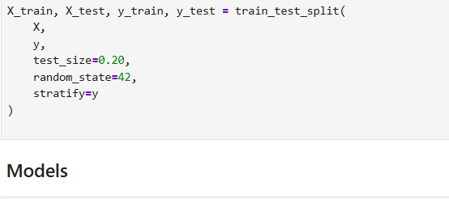

- Models

models = {
"Decision Tree": DecisionTreeClassifier(
max_depth=10,
min_samples_leaf=5,
random_state=42

),

"Random Forest":RandomForestClassifier(
n_estimators=300,
max_depth=15,
min_samples_split=5,
random_state=42

),

"Logistic Regression": LogisticRegression(
max_iter=5000,
solver="lbfgs",
multi_class="multinomial"
),

"XGBClassifier": XGBClassifier(
n_estimators=200,
learning_rate=0.05, random_state=42)
)
}
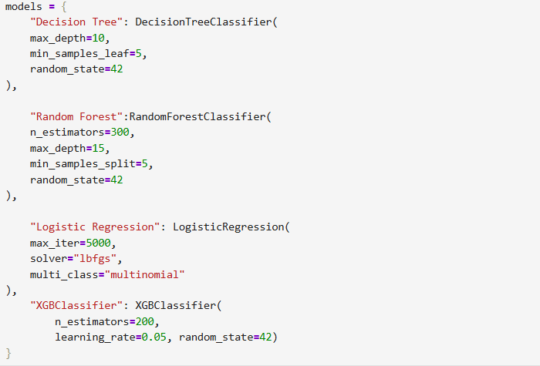

- Train & Evaluate
Four major evaluation metrics were used:

1. Accuracy
Accuracy represents the proportion of total predictions that were correct.
Accuracy = Correct Predictions / Total Predictions
A higher accuracy indicates that the model correctly classified a larger percentage of test records.

2. Precision
Precision measures how many records predicted as a particular class actually belonged to that class.
It is useful for understanding the reliability of positive predictions.

3. Recall
Recall measures how many actual records belonging to a class were successfully identified by the model.
In healthcare-related analysis, recall can be important when failing to identify a particular outcome may be important.

4. F1-Score
F1-score combines precision and recall into a single metric.
It is particularly useful when we want to evaluate the balance between precision and recall.
In this project, weighted precision, recall, and F1-score were used so that the contribution of each class was considered according to its number of records.

results = []

for name, model in models.items():

# Train model
model.fit(X_train, y_train)

# Predict test data
y_pred = model.predict(X_test)

# Evaluation metrics
accuracy = accuracy_score(y_test, y_pred)

precision = precision_score(
y_test,
y_pred,
average="weighted",
zero_division=0
)

recall = recall_score(
y_test,
y_pred,
average="weighted",
zero_division=0
)

f1 = f1_score(
y_test,
y_pred,
average="weighted",
zero_division=0
)

results.append({
"Model": name,
"Accuracy": accuracy,
"Precision": precision,
"Recall": recall,
"F1-Score": f1
})

print("\n", name)
print("Accuracy:", accuracy)

print(
classification_report(
y_test,
y_pred,
target_names=target_encoder.classes_,
zero_division=0
)
)

print("Confusion Matrix:")
print(confusion_matrix(y_test, y_pred))

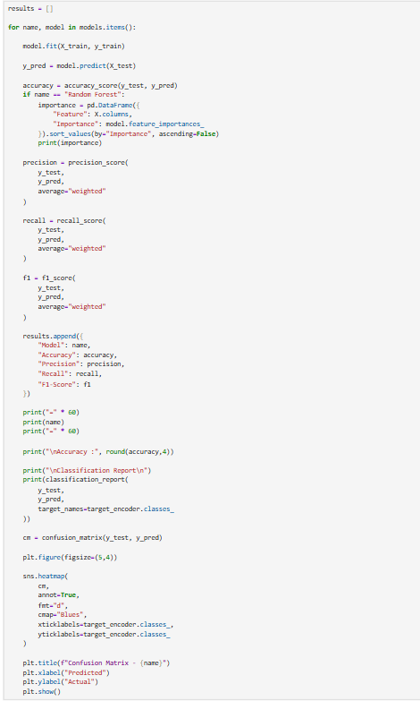
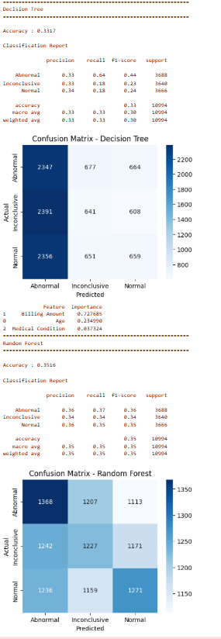
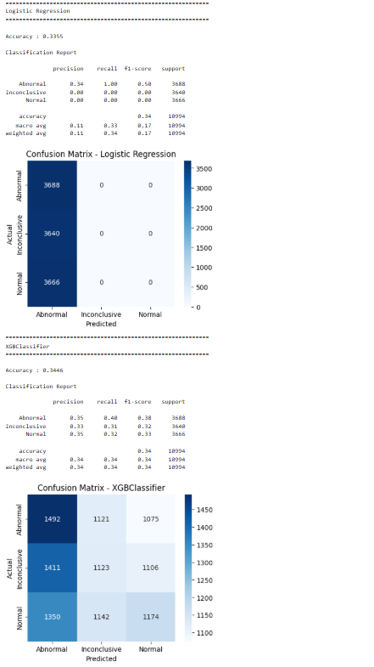
- Comparison Table

results_df = pd.DataFrame(results)

print("\n")
print(results_df)
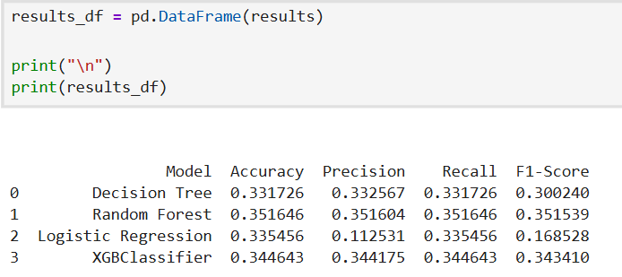

Decision Tree
The Decision Tree achieved approximately 33.17% accuracy. Its weighted F1-score was approximately 0.3002.
The model performed poorly overall and showed uneven predictions between the three classes. A single decision tree can identify non-linear patterns, but the selected healthcare features did not provide sufficient information for reliable test-result prediction.

Random Forest
Random Forest produced the strongest overall performance:
- Accuracy: 35.16%
- Precision: 35.16%
- Recall: 35.16%
- F1-score: 35.15%
Random Forest combines predictions from multiple decision trees. This generally provides more stable predictions than relying on one individual tree.
However, the improvement over the other models was small. Therefore, Random Forest should be described as the best-performing model in this experiment, not as an accurate clinical prediction model.

Logistic Regression
Logistic Regression achieved approximately 33.55% accuracy, but its weighted precision and F1-score were much lower.
The confusion matrix showed that Logistic Regression predicted essentially all test records as Abnormal.
This is an important example of why accuracy alone should not be used to evaluate a classification model.
Although its accuracy was around 33.55%, it failed to meaningfully distinguish between Abnormal, Inconclusive, and Normal cases.

XGBoost
XGBoost achieved approximately:
- Accuracy: 34.46%
- Precision: 34.42%
- Recall: 34.46%
- F1-score: 34.34%
It performed better than Decision Tree and Logistic Regression on the overall weighted metrics but remained slightly below Random Forest.
The result also shows that using a more advanced boosting algorithm did not produce a major improvement.

- Best Model

best_model = results_df. loc[
results_df["Accuracy"].idxmax()

print("\nBest Model")
print(best_model)
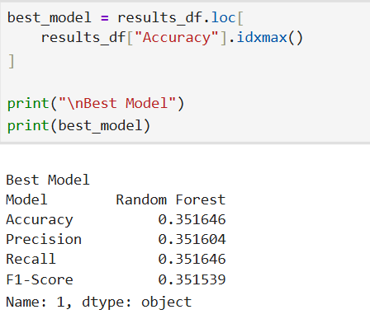

- Accuracy Comparison Plot

plt.figure(figsizc-(8,5))

sns.barplot(
data-results_df,
x="Modcl",
y-"Accuracy"

plt.title("Model Accuracy Comparison")

plt.ylim(0,1)

for i,v in emumerate(results_df["Accuracy"]):
plt.text(i,v+D.01,f"(v :. 3f)",ha-"center")

plt.show()
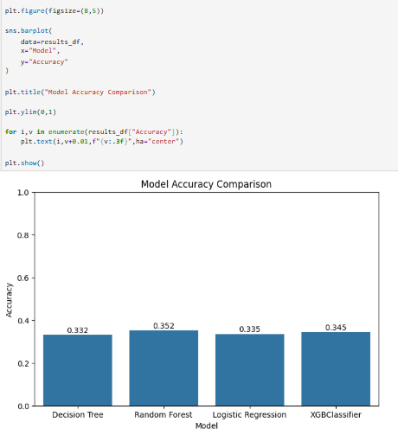

- Conclusion

Week 4 focused on statistical analysis and predictive modeling of the healthcare dataset. Descriptive statistics, frequency analysis, and correlation analysis were first used to understand the characteristics and relationships within the data. Predictive modeling was then performed using Test Results as the target variable.
Decision Tree, Random Forest, Logistic Regression, and XGBoost were trained and evaluated using an 80:20 train-test split. Instead of relying only on accuracy, the models were compared using accuracy, precision, recall, F1-score, classification reports, and confusion matrices.
Random Forest achieved the strongest overall performance with approximately 35.16% accuracy and a 35.15% weighted F1-score, followed closely by XGBoost with approximately 34.46% accuracy. Logistic Regression demonstrated why multiple evaluation metrics are necessary: although its accuracy was approximately 33.55%, its confusion matrix showed that it predicted almost every test record as Abnormal.
Overall, the relatively low performance across all models indicates that the selected healthcare features contain limited predictive information for Test Results. This is an important finding because it demonstrates that machine learning performance depends strongly on feature relevance and data quality, not simply on algorithm complexity. Future work should therefore focus on collecting richer clinical variables and improving feature engineering before developing more advanced predictive models.

